Reach Out and Read and Cub Pack 133

Cub Pack 133 will be collecting new and gently used book for children 6 months to 5 years. Children’s Hospital of Philadelphia has a program called Reach Out and Read. This program is designed to gets books into the hands of children in need through their primary care physicians.

Reach Out and Read is in need of pictures books and board books for young children. Please look through your children’s books, visit a second hand store or pick up a new book while doing your holiday shopping. The Pack will be collecting books until our December 19th meeting.

Trunk or Treat
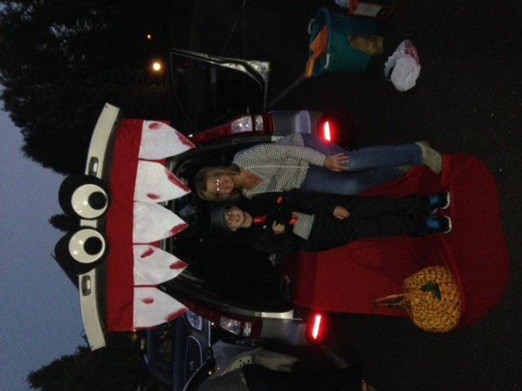
The Girl Scouts and Cub Pack 133 joined together for their 3rd Annual Trunk or Treat Event. With all the kids and cars in costumes, the scout had a night of candy and games. The scouts voted and prizes were handed out to the top three cars. The New Britain Food Larder benefits from this event, as the scouts must bring a donation in order to participate. A great night for all!!
