Girl Scouts - Update

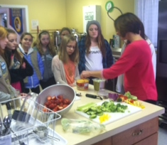
Girl Scout Cadette Troops 21309 and 2056 have been busy the last few weeks!
We kicked off the New Year by meeting with a nutritionist to help the girls earn the Eating for Beauty badge. Topics discussed were eating for energy and health, organic vs. non organic and making healthy eating a lifestyle. The girls made food they could eat for breakfast and lunch as well as a snack to see how easy it is to eat healthy.

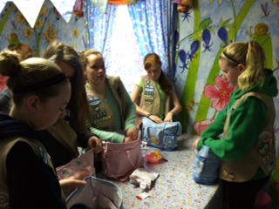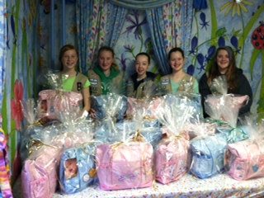

We ended 2014 by partnering with Fabby Shabby Grab Bag Boutique in Doylestown to stuff and wrap diaper bags that would be given to needy teen and young single mothers for Christmas. The girls stuffed the diaper bags with lots of baby necessities that were collected by Fabby Shabby during a collection drive. The bags were then wrapped, topped with ribbon then on their way to the moms.

The Girl Scouts would like to thank CUMC for their continued support especially with the use of the facilities for our meetings and activities.
Boy Scouts - Update

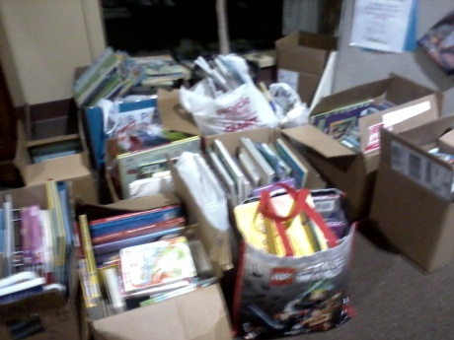
"Cub Pack 133 had huge success with the book drive for Children's Hospital of Pennsylvania's Reach Out and Read Program. It is estimated that we collected about 1,000 books. Definitely too many to count. A big thank you to all of the church members who made donations. A representative from the Reach Out and Read Program came out and talked to the boys about how important these books are for other children in the surrounding communities. Next up for the scouts are the Pinewood Derby Races, one of the most exciting events of the year. "

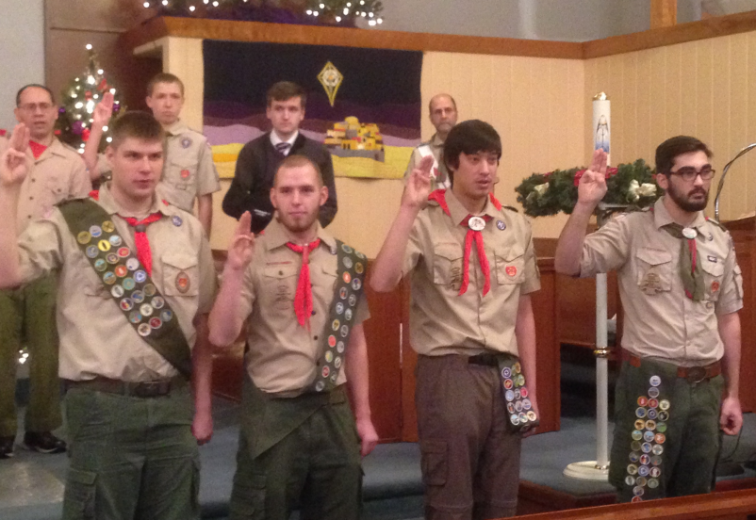

Saturday, January 3, 2015
Celebrate the achievement of Eagle rank

Pictured - Matthew Coleman, Andrew Montgomery, Kieran Fung and Eric Armitage
Boy Scout Troop 133 was proud to celebrate the achievement of Eagle rank for four of its members. To reach the rank of Eagle the boys had to meet many requirements, the last of which is a service project.

Their projects were:
Matthew Coleman built an elevated walkway to an open air classroom in a flood prone area behind Unami Middle School.

Andrew built 6 bat houses to combat the drop in local bats. The bat houses were erected in New Britain Township's North Branch Park.

Eric repaired and repainted the pavilion at the Doylestown Senior Center.

Kieran enlarged our church community garden, doubling its capacity, providing a bounty for the community.

Our troop has been involved in many community activities such as: planting American flags at the John Neumann Cemetery on Memorial Day along with the VFW, demonstrating our cooking and camping skills at the Fall New Britain Festival, and helping the Lions Club to sell Christmas trees at Spatola's Pizza Shop.

Upcoming events are:
Lenape District Klondike Derby on Jan 24th, where we will compete using our outdoor skills with other local troops, plus do some winter camping.
Scout Sunday is February 8th and we will be participating in the services at church.
Last is the 40th annual Scout Spaghetti dinner held here at the church on Saturday, March 14th, 4-7 PM. We hope you will support us.

